1. ChatGPT
Create a professional promotional image of young travellers inside a modern airport terminal. Use blue and white brand colours, natural lighting and a landscape layout. Do not include airline logos or text.
for Airline advertisements
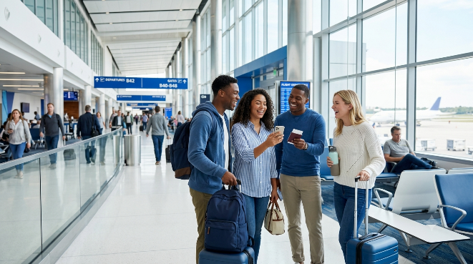

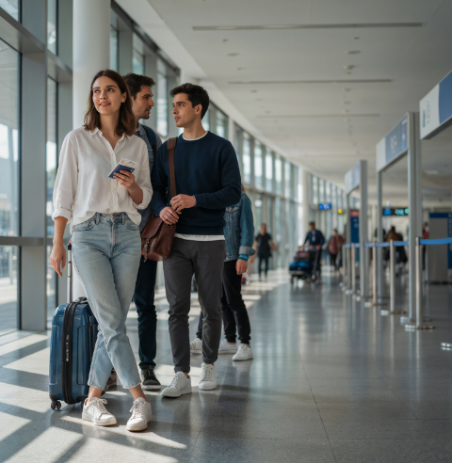
2. Ideogram
Create a professional promotional image of young travellers inside a modern airport terminal. Use blue and white brand colours, natural lighting and a landscape layout. Do not include airline logos or text. for Airport social-media campaigns

3.Gemini
Create a professional promotional image of young travellers inside a modern airport terminal. Use blue and white brand colours, natural lighting and a landscape layout. Do not include airline logos or text.
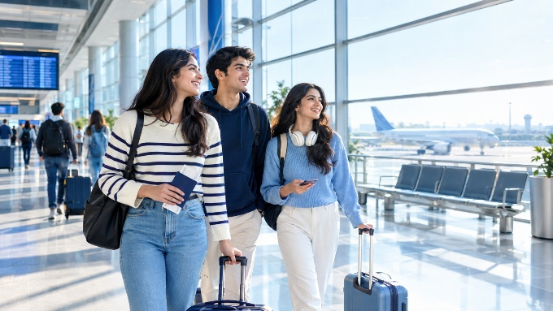

4. Perplexity
Create a professional promotional image of young travellers inside a modern airport terminal. Use blue and white brand colours, natural lighting and a landscape layout. Do not include airline logos or text.
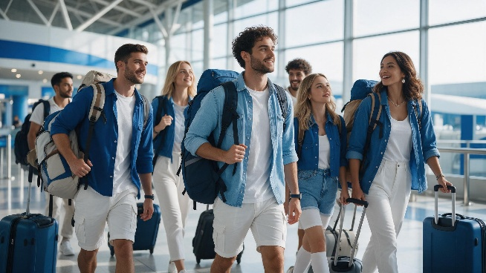
For Destination-marketing visuals

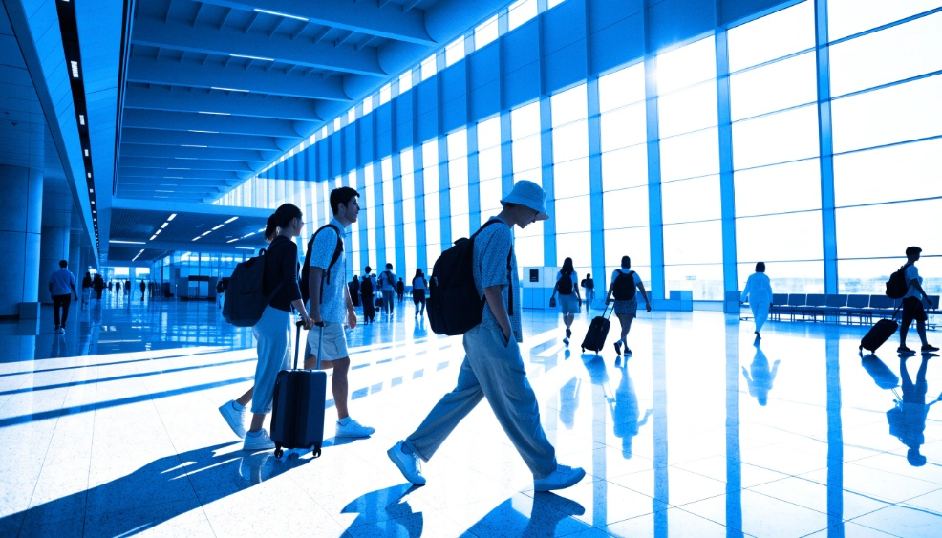
5. Leonardo Ai
Create a professional promotional image of young travellers inside a modern airport terminal. Use blue and white brand colours, natural lighting and a landscape layout. Do not include airline logos or text.

6. Adobe Firefly
Create a professional promotional image of young travellers inside a modern airport terminal. Use blue and white brand colours, natural lighting and a landscape layout. Do not include airline logos or text.Presentation backgrounds
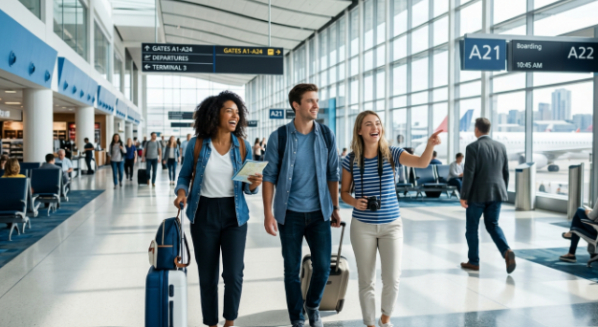

7.DeepAI
Create a professional promotional image of young travellers inside a modern airport terminal. Use blue and white brand colours, natural lighting and a landscape layout. Do not include airline logos or text. For Loyalty-programme campaigns
